

Background: Families of Fallen Service Members
Traveling to Hawaii for Participation in Honorable Carry Ceremony
Tuesday, July 31, 2018 – Wednesday, August 1, 2018

- BACKGROUND

Diana Brown Sanfilippo
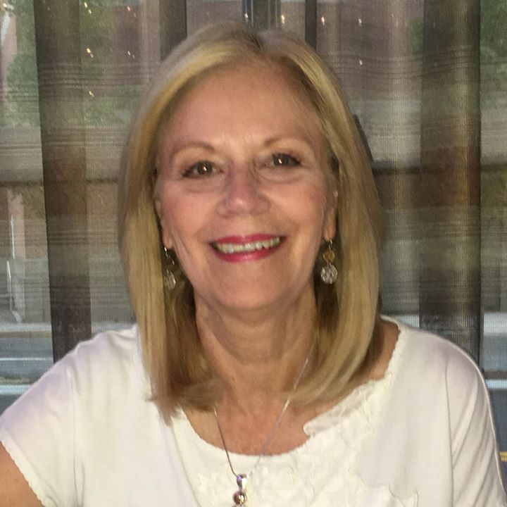
Diana has spent a lifetime searching for her father, First Lieutenant Frank Salazar, who died 66 years ago in North Korea. Her memories of him are as a four-year-old, saying goodbye to him at an airbase, little else. She has had to build the rest almost literally from scratch, a decades-long struggle often with little help. She was in her teens before she saw a picture of him in his aircraft and learned of his fate during the Korean War, when his P-51 was hit by ground fire and lost over North Korea. She grew up, went to college, and became a marriage and family therapist. She credits that training with helping her eventually recognize and deal with her struggle. It also helped, she says, when in 1998 the Air Guard, marking its 50th anniversary, recognized Salazar as their only combat fatality and presented the family with a plaque. However, the path forward came into focus three years later on September 11th.

"I watched the towers fall and it was really emotional for me. I know it was emotional for everybody. I knew there would be families who would have their loved ones missing. And so I thought, 'I really have to tell my story because this is happening to other people.'"

Determined to feel a deeper connection to her father, Diana took flying lessons, eventually taking the controls of a P-51, the aircraft her father loved. Earlier this year, Lt. Salazar got his ceremony, a military funeral and marker at Arlington National Cemetery.

Diana has completed a book about her struggle: "Fly-by: A Daughter's Journey from Tragedy to Tribute." It is due for release this fall.

Diana will be accompanied on the trip by her husband, Robert Sanfilippo, and will join the flight from Travis Air Force Base in California. Coincidently, it was at Travis Air Force Base where her father deployed from in 1951 and where she remembers her last memory of him.

"I remember him hugging me when we dropped him off at the airbase, and telling me he loved me and to be good to my mommy."

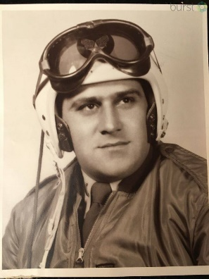
First Lieutenant Frank Salazar (deceased) – “Along with the rest of the Nevada Air National Guard, 1st Lt. Frank Salazar was called to active duty in March of 1951. The Korean War was by then in its ninth month. At home, the debate over the conduct and scope of the war raged. In Korea, things had settled into a violent stalemate. His unit was stationed stateside, but Salazar volunteered for duty in the war zone. On December 31, 1952, his P-51 was hit by ground fire on a reconnaissance mission over North Korea. He was listed as missing in action and, after a year, declared dead. His widow moved on, and remarried. Records show she received a shipment of his belongings, but never shared it with her children, refused to talk about him, even answer their questions.”

Rick Downes

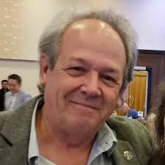
Rick Downes was only three years old when his father Hal went off to the Korean War. He's been missing ever since. Rick was too young to remember his father, so all he has is a home movie of a 26-year-old man with everything to live for.

Rick serves as the President and Executive Director of The Coalition of Families of Korean and Cold War POW/MIAs, whose mission is to promote the fullest possible accounting for American servicemen who remain prisoners-of-war or missing-in-action from the Korean and Cold Wars. In this role, in 2016, Rick flew to Pyongyang to press for the return of not just his father's remains, but also those of the 5,300 American service members still missing in action in North Korea.

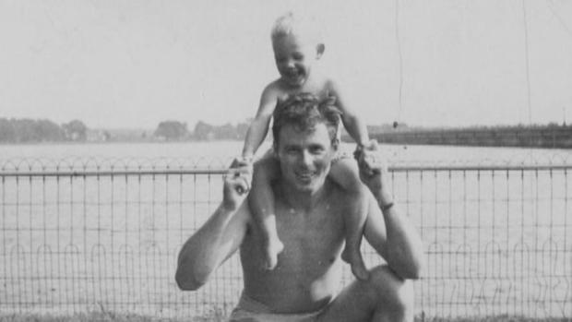
Lieutenant Hal Downes (deceased) – US Air Force Lieutenant Hal Downes was a radar operator in the rear of a B-26 bomber that went down during a mission over North Korea in 1952. While the pilot and navigator were able to bail out during the crash, Hal was lost and was never recovered.

From his son, Rick: “He was kind of a good guy, I think, and he had a lot going for him. He had gone into World War II as a young man and got a lot of training in in the Air Force and then never actually got to action. The war ended. And then got married to my mom, and they had me, and he went off to the University of Michigan and graduated - a business degree. Got a job at Kaiser Auto. And, very first day he was there, my mom got a telegram saying he'd been recalled to the Korean conflict. And his comment was, he hadn't even sharpened his pencil.”

- ARTICLES

Attached

http://www.kolotv.com/content/news/Daughter-of-Korean-War-MIA-waits-for-closure-487273141.html
Daughter of Korean War MIA waits for closure
By Ed Pearce |
Posted: Tue 3:38 PM, Jul 03, 2018 |
Updated: Wed 8:27 AM, Jul 04, 2018
STATELINE, Nev. (KOLO) "You don't have closure. You may never have closure. But you have to be able to be at peace with that."
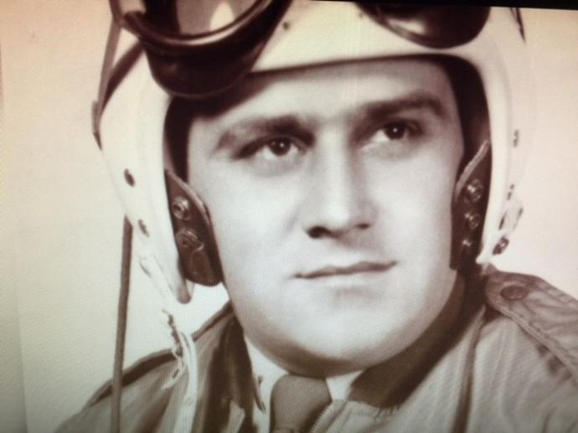
Diana Brown Sanfilippo has spent most of her life searching for that peace and connections to a father she lost 66 years ago.
Her memories of him are as a 4-year-old, saying goodbye to him at an airport, little else. She's had to build the rest almost literally from scratch, a decades-long struggle often with little help.
First Lt. Frank Salazar, along with the rest of the Nevada Air National Guard, was called to active duty in March of 1951. The Korean War was by then in its ninth month. At home the debate over the conduct and scope of the war raged. In Korea things had settled into a violent stalemate. His unit was stationed stateside, but Salazar volunteered for duty in the war zone.
December 31, 1952, his P-51 was hit by ground fire on a reconnaissance mission over North Korea. He was listed as missing in action and, after a year, declared dead. His widow moved on, and remarried.
Records show she received a shipment of his belongings, but never shared it with her children, refused to talk about him, even answer their questions.
"It was like there was never any picture, no talk. I didn't know what happened. And then another man comes in and he's my dad and I don't know anything."
She was in her teens before she saw a picture of him in his aircraft and learned of his fate.
"You know, it kind of impressed me," she says of the picture, one of the few she has. "And then she tells me 'He's missing. They never found him.'"
"All this stuff goes through my mind even as a child. Was my dad tortured? Was he still alive? Did he live through the plane crash? All I have is questions and no one wants to answer or even talk about him."
She says now that she and her brother paid a price for that lack of knowledge, any connection to their father, left with questions, no answers. They didn't even share their loss with each other. She notes they never smiled in family photos taken later.
"I would say I was probably depressed most of my life because there's like this sadness in me."
She grew up, went to college, became a marriage and family therapist. It may have been that training that helped her eventually recognize and deal with her struggle.
"I knew I had to figure this out but I didn't know how."
It helped, she says, when in 1998 the Air Guard, marking its 50th anniversary, recognized Salazar as their only combat fatality and presented the family with a plaque. But the path forward came into focus three years later on September 11th.
"I watched the towers fall and it was really emotional for me. I know it was emotional for everybody. I knew there would be families who would have their loved ones missing. And so I thought, 'I really have to tell my story because this is happening to other people.'"
She began putting her struggle into words, writing about her loss. Then in 2007 her husband, Bob, researching for her online, found a reference to her father. .
"He said, 'Your Dad's name is here and there's a request for DNA' and I thought 'Oh my gosh.'"
She thought for a moment he'd been found, but when she called it was from the casualty office at Randolph Air Force Base. They wanted DNA to help them identify any returned remains.
Another posting led her to a retired colonel, her father's best friend in Korea. He was looking for any of Frank Salazar's family.
"And he talked with me about the two of them flying and it gave me a sense of how much my dad loved to fly. And so, I knew that was how I was going to connect with my dad. So I became a pilot."
Later she paid a princely fee to take the controls of a P-51, the aircraft her father loved. Finally earlier this year, Lt. Salazar got his ceremony, a military funeral and marker at Arlington National Cemetery.
"He was forgotten. He was never talked about and I wanted to bring him back to life. I wanted him to have a legacy. He existed even though I grew up as if he never existed. And there needed to be a service to have that happen."
She says she is now at peace with her loss, though closure still eludes her.
"I wouldn't say there's total closure because it does not feel good to me that his remains are in a hostile country. To have him home would be closure for me, but I know that may never happen."
That doesn't mean she's not hopeful.
"I have hope and I don't have hope because of the history of North Korea not turning over remains when they said they would."
Diana says she's not waiting for that call. The North Koreans have failed to keep those promises before. Still, she says, news of any returns will be welcome to all.
"Us family members who share this same loss are happy for any other family member. Even if our own doesn't come home we share the joy with the other who does."
There are more than seven thousand US servicemen unaccounted for in the Korean War. Frank Salazar is one of five Nevadans in that number. The chance that his remains would be among the 200 or so promised for return are slim.
Diana has completed a book about her struggle: "Fly-by: A Daughter's Journey from Tragedy to Tribute." It will be released this fall.
And she maintains a Facebook page for families of missing persons. You'll find it here.

https://www.cbsnews.com/news/son-of-fallen-korean-war-soldier-hopes-to-finally-lay-his-father-to-rest/
By DAVID MARTIN CBS NEWS July 26, 2018, 6:40 PM

Son of Korean War soldier hopes to finally lay his father to rest
PORTSMOUTH, N.H. — Rick Downes was 3 years old when his father Hal went off to the Korean War. He's been missing ever since.
"I call it the wound that never heals," Downes said. "After a while you get used to having it and it finds a place within you, and you go on, you live life."
He was too young to remember his father, so all he has is a home movie of a 26-year-old with everything to live for.
"You just can't help but look at him and see that he had it together. He had the woman he wanted, he had the family he wanted," Downes said.
Hal Downes was a radar operator in the back of an Air Force bomber which went down during a mission over North Korea. The pilot and navigator were able to bail out, but they didn't know what happened to Rick's father.
Hal Downes served in the Korean War.
RICK DOWNES
"The navigator said the plane went down over — finally crashed over a hill and he heard the ammunition going off, and that's all. That's all we know," Downes said.
Two years ago, he flew to Pyongyang to press for the return of not just his father's remains but also those of the 5,300 American servicemen still missing in action in North Korea.
"When I got to go to North Korea, we flew in over where we think my dad's plane went down," Downes said.
"It was all there. The hills that the navigator said the plane went down, there they were," he explained. "It's the closest I've been to him proximity wise since I was 3, and just you never forget that."
Now he is coming close again, this time with a promise by Kim Jong Un to President Trump to return of remains from the war, a promise not yet delivered on.
"You have to really watch your heart here because this all could just fizzle. This could be nothing. It could be everything," Downes said.
Whether Hal Downes ever receives a proper burial is in the hands of the North Koreans. But when you visit the National Mall you will find his image etched into the stone of the Korean War memorial — the face of the missing.
© 2018 CBS Interactive Inc. All Rights Reserved.
David Martin is CBS News' National Security Correspondent.

Source: KOLO News July 3, 2018 by Ed Pearce
Source: CBS News July 26, 2018 by David Martin

